Feature | Git | GitHub
Core Function | Version Control System (VCS). | Cloud Storage or Cloud Platform.
Location / Storage | Saves locally. It stores different versions on your computer. | Stores code online (in the cloud).
Accessibility / Visibility | Offline. Only the user can see the code changes locally. | Share Online and Collaborate Online. This allows everyone to see and comment on the code.
Purpose | To track changes (சேஞ்சஸ ட்ராக் பண்றது) within the code. | To move the locally saved content to a cloud storage platform.
Analogy | Like typing a message in a group chat before hitting send; only the user can see it. | Like hitting the "Send" option in the chat, allowing everyone to see the message. It is comparable to Google Drive.

YT : 🚨(AI ENGINEERS STOP!) Git & GitHub இல்லாம IT Career Start பண்ணாதீங்க⛔ | Step by Step Practical Demo



CHEAT SHEET
Description | Git Commands
Configure Git | git config -global user.name "Your Name"
 | git config -- global user.email "your@email.com"
Start a new repo | git init
To check status | git status
Clone an existing repo | git clone <url>
Prepare to commit
Add untracked file or unstaged changes | git add <file>
Add all untracked files and unstaged changes | git add.
Unstage one file | git reset <file>
Unstage everything | git reset <file>
Check what you added | git status
Make Commits
Make a commit (and open text editor to write message) | git commit
Make a commit | git commit -m 'message'
Commit all unstaged changes | git commit -am 'message'

========================================
Here is the list of Git commands discussed and used in the demonstration:

### I. Setup and Configuration Commands

These commands are used after installing Git and signing up for GitHub to verify the installation and link your local Git configuration to your GitHub credentials:

1. **Verify Git Installation:**
* **`git`**
* *Purpose:* Used in the Command Prompt (CMD) to check if Git is installed correctly by displaying a list of available commands.
2. **Configure User Name:**
* **`git config --global user.name "your_username"`**
git config --global user.name "Gokul140989"

* *Purpose:* Connects your local Git system to your specific GitHub username.
3. **Configure User Email:**
* **`git config --global user.email "your_email"`**
git config --global user.email "gokulkrishds@gmail.com"
* *Purpose:* Connects your local Git system to the email address used for your GitHub account.

### II. Local Repository Management Commands

These commands turn a local folder into a functional Git repository, track changes, and save versions locally:

1. **Initialize Repository:**
* **`git init`**
* *Purpose:* Initializes Git for the current project folder, resulting in an "Initialized empty Git repository" message in the local system.
2. **Stage Files (Add):**
* **`git add file_name`** (Example: **`git add notes.txt`**)
* *Purpose:* Instructs Git to start tracking a specific file and stages the changes made to it.
3. **Commit Changes (Save Version):**
* **`git commit -m "message"`** (Examples: **`git commit -m "My first commit"`**; **`git commit -m "Added second line"`**)
* *Purpose:* Records the staged changes locally with a descriptive message, confirming the change (e.g., "One file change, one insertion").
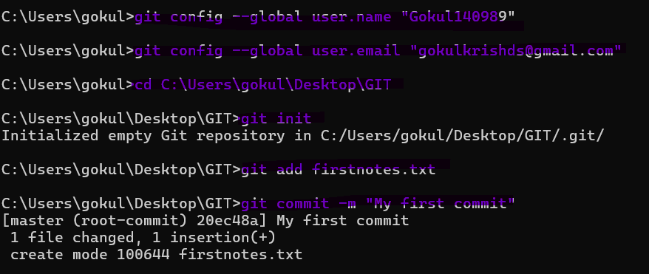
### III. Remote Repository Connection and Upload Commands

These commands connect the local repository to the remote GitHub repository and push the committed work online:

1. **Connect Local to Remote:**
* **`git remote add origin ...`**
* *Purpose:* This command (which is provided by GitHub upon repository creation) connects the local system to the specified GitHub repository, enabling subsequent movement of files.
2. **Set Branch Name:**
* **`git branch -M main`**
* *Purpose:* Ensures the local branch is named 'main' (in case it defaults to 'master' on some systems).
3. **Push Changes to GitHub:**
* **`git push -u origin main`**
* *Purpose:* Uploads the locally committed changes to the remote repository on GitHub.

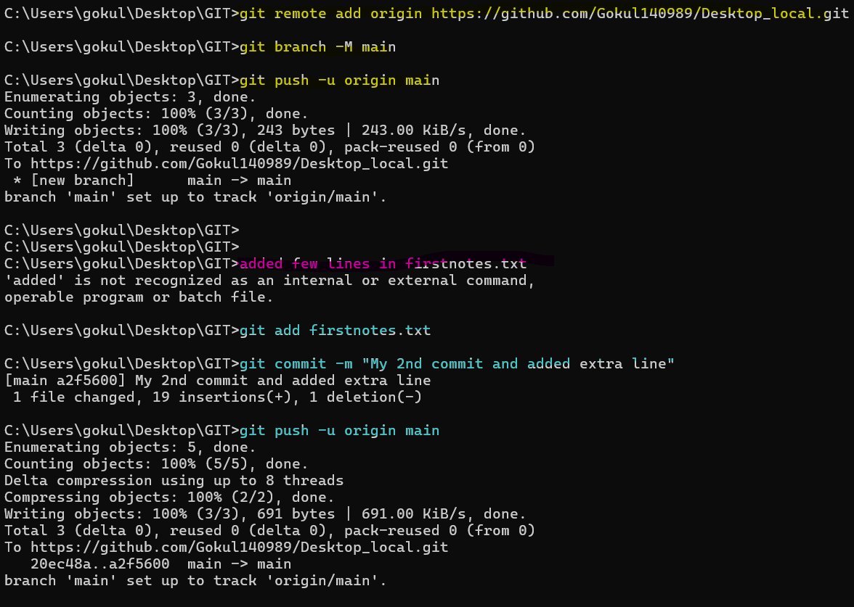
### IV. Other Relevant Terminology

While not commands in the cheat sheet, the source also introduces crucial collaborative concepts implemented via Git and GitHub:

* **Branching:** Creating separate workspaces (**தனித்தனி பிரான்ச்**) for individual team members to work on specific features without disturbing others' work.
* **Merging:** Combining (**கம்பைன்**) all the feature branches back into the main branch after the work is complete.
* **Pull Request:** A request raised before merging, asking a higher authority (like a manager) to review and approve the code changes.

======================
EXAMPLES:
The primary example used to explain the concepts of Git and GitHub to beginners was an analogy based on Trip Planning.
The speaker titled this concept explanation "From Trip Planning to Code Planning" (ஃரம் ட்ரிப் பிளானிங் டு கோட் பிளானிங்). This analogy was presented in a story format using a "Friends theme".
Details of the Trip Planning Example
The scenario revolves around a group of friends (from college or work) who decide to plan a trip to a dream destination, specifically mentioning Goa.
This trip planning scenario was used to illustrate key Git and GitHub concepts:
- Task Splitting and Collaboration: Once the friends decide to go, they split up the necessary tasks.
  - One person might say, "I will book the room".
  - Another person might check the transport options, such as car, bus, or flight.
  - A third person might handle the budget calculations.
  - This splitting of different tasks among different people relates directly to how separate tasks are handled in a development environment.
- Version Control (Git): Planning the trip involves tracking changes.
  - First, the group brainstorms initial ideas for places, spots, and adventurous activities (like water sports).
  - Later, a person might suggest adding new spots to the itinerary.
  - Tracking these small, continuous changes (like tracking changes within a product development team of 25 members who are building prototypes and adding features) is the essence of Version Control, which is what Git handles.
- Local vs. Cloud Storage (Git vs. GitHub):
  - Git (the local system) is compared to typing a message in a group chat; only the user can see it. Git saves locally.
  - GitHub (the online platform) is compared to clicking the "Send" option in the chat, allowing everyone to see the message. GitHub is a cloud storage platform, like Google Drive, where the code is stored and can be accessed from anywhere (shared online).
- Branching, Merging, and Pull Requests:
  - Branching: If two friends have conflicting ideas (e.g., one booked a room, but another says they should cancel it because they are only trekking), it creates confusion. To avoid this, developers work on separate tasks (like a home page or a login page) in separate spaces or separate branches (தனித்தனி பிரான்ச்) without disturbing each other's work.
  - Merging: Just as all friends' inputs (room booking, transport, etc.) are needed to finalize the trip plan, all developed features must be combined (கம்பைன்) into the main branch once the work is done. This process is called Merging.
  - Pull Request: Before finalizing the trip, friends share the itinerary and ask, "Is this okay for everyone?" This request for review and approval is analogous to the Pull Request. A Pull Request is a request raised to a higher authority (like a manager) to check if the code is correct before pushing it to the main branch.

